**Approval for Go No Go for Ramp process:**

Always the transition manager takes approval from client before proceeding to ramp phase.

The following is the screen shot for Ramp approval.

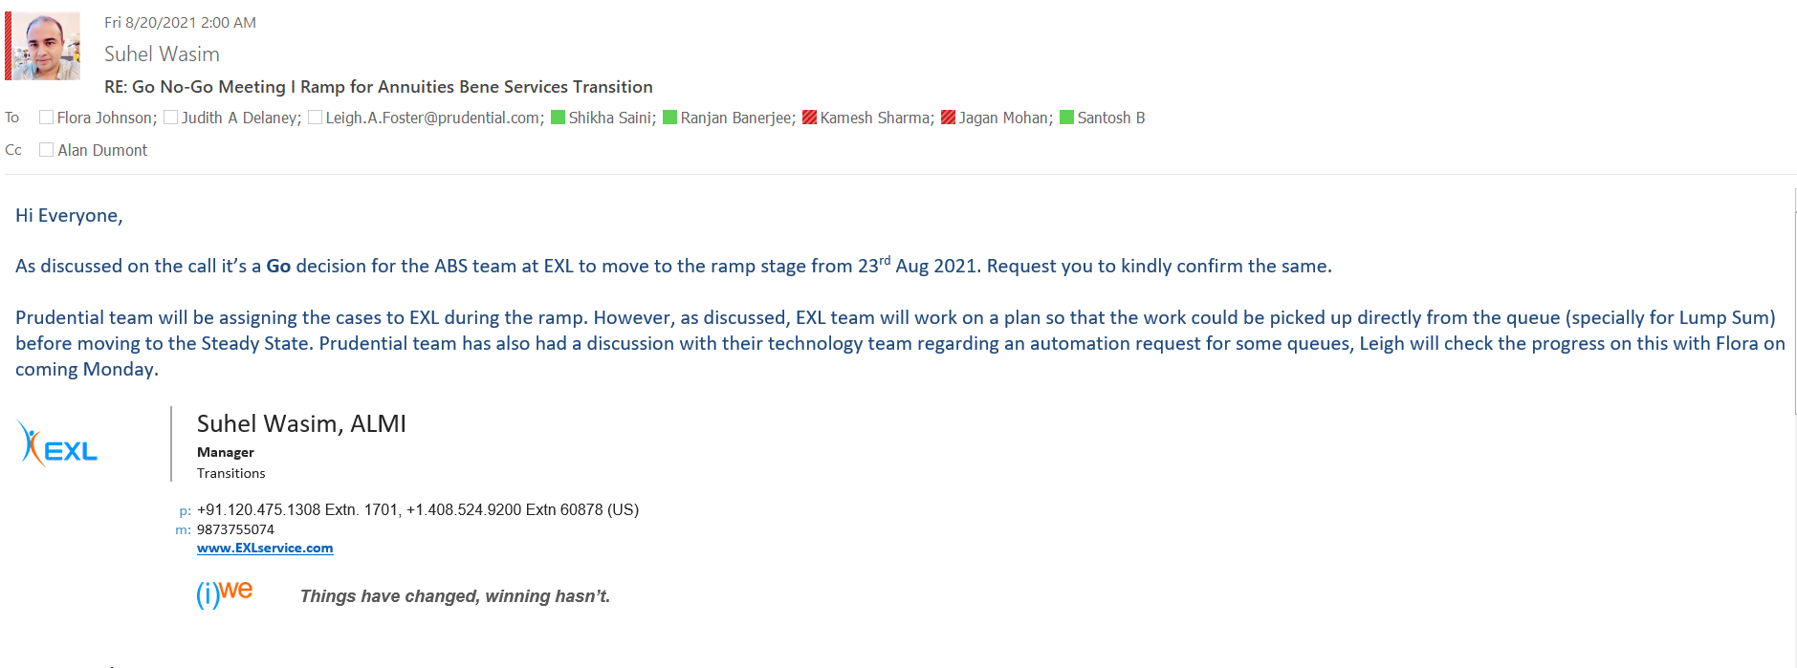

Note: Kindly take note that the transition manager always forwards the email of the meeting invite & then writes the approval email so that it becomes audit proof that a separate meeting was conducted & approval was taken from client

In the below screen shot if you see the transition manager has forwarded or used the invite email itself & then taken approval.